SHARED FOUNDATION GUIDE
The Four Things We All Need to Know
Attack Path Risk Engine — for Mohamed, Rahsheetha & Kithiyon

This is the shared foundation everyone on the team should be comfortable with before splitting into specialisations. None of this requires mastery — just enough to follow what's happening in the graph, explain it to a panel, and know where your own module fits into the bigger picture.

1. Basic Python — With Context to Our Project
Path Discovery and Risk Scoring (Layers 1 and 2 of our architecture) are both plain Python. You don't need to be a strong programmer — you need to be comfortable with four things: variables, functions, loops, and dictionaries/lists, because that's literally what a graph query result looks like once it lands in Python.

Why dictionaries and lists specifically matter here
When you run a Cypher query from Python, Neo4j doesn't hand you a picture of a graph — it hands you a list of dictionaries, one per row. Getting comfortable reading these is 80% of what you need.
What a query result actually looks like in Python
# One path returned from Neo4j looks like this:
path_result = {
"start_node": "i-0abc123", # the EC2 instance
"hops": ["AssumeRole", "PolicyAttach"],
"end_node": "prod-data-bucket", # the sensitive target
"hop_count": 2
}

# A tiny function using it — this is close to real code you'll write:
def score_path(path):
decay = 0.85 ** (path["hop_count"] - 1)
return decay * len(path["hops"])
If that snippet makes basic sense — a function, a dictionary, a loop-shaped idea — you already have what you need to start. Everything else (AWS SDK calls, Neo4j driver syntax) is copy-adapt-understand, not memorise.

Where to actually practice
- W3Schools Python or Python.org's official tutorial for the absolute basics of syntax.
- Once comfortable, skim Cartography's own source code (any small intel module) rather than a generic course — you'll learn Python and the project's structure at the same time.

2. Graph Databases & Basic Cypher
A graph database stores two kinds of things: nodes (the "things" — a user, a server, a bucket) and relationships (the "connections between things" — assumes, can access, runs as). That's it. Everything Cartography and Neo4j do is built on just these two ideas.
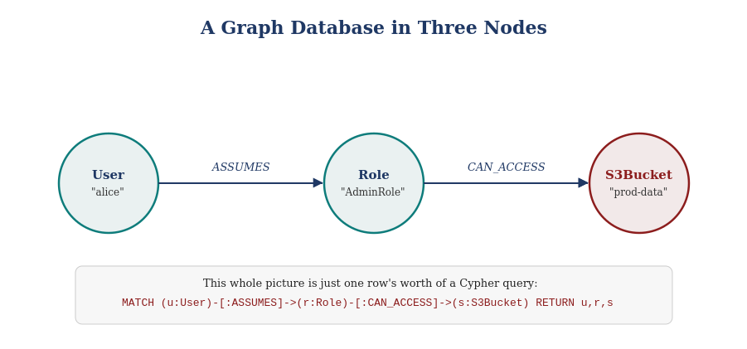
Figure 1. Three nodes and two relationships — this is the entire mental model.

Reading Cypher — the four pieces you actually need
- MATCH — describes the pattern you're looking for (like the picture above, written as text).
- Arrows -[:TYPE]-> — show a relationship and its direction.
- WHERE — filters results by a property (e.g. only exposed servers).
- RETURN — says what you actually want to see.
"Find all paths between A and B" — the exact shape our project needs
MATCH path = (entry:AWSEC2Instance {exposed_internet: true})
-[*1..4]->
(target:S3Bucket {name: "prod-data-bucket"})
RETURN path

# In plain English: "Find every route, of at most 4 hops, from any
# internet-exposed EC2 instance to this specific S3 bucket."
That query IS the core idea of our Path Discovery layer, just written by hand instead of generated automatically. Once this makes sense, you understand the single most important concept in the whole project.

Where to actually practice
- Neo4j's own free "Cypher Fundamentals" course (graphacademy.neo4j.com) — a few hours, hands-on, no fluff.
- Then go straight to Cartography's own querying tutorial and try their canned queries against your own synced sandbox data.

3. Core Cloud Security Concepts
Four terms come up constantly in this project. You don't need a security background — these are genuinely simple ideas once you see them laid out as a chain.

IAM roles, privilege escalation & lateral movement
An IAM role is just a named bundle of permissions that a user or a service can "put on" temporarily. Privilege escalation means ending up with more access than you started with. Lateral movement means hopping sideways to a different resource. Attackers usually do both, repeatedly, to get from "barely any access" to "the production database."
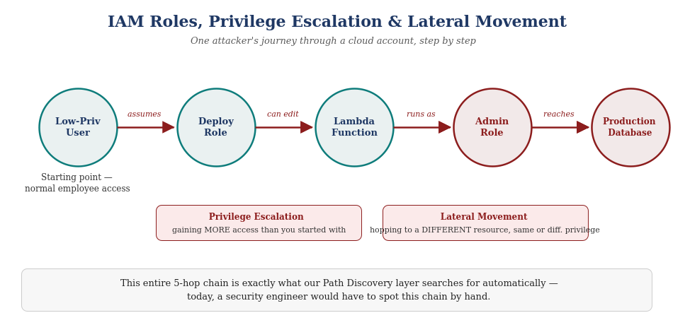
Figure 2. A realistic 5-hop chain — exactly the shape our Path Discovery layer searches for.

Blast radius
Blast radius is simply: "if this one thing gets compromised, how much else can the attacker reach from here?" A small blast radius is low risk. A blast radius that reaches production data is high risk — and it's exactly what our 0–100 Risk Score is trying to estimate numerically.
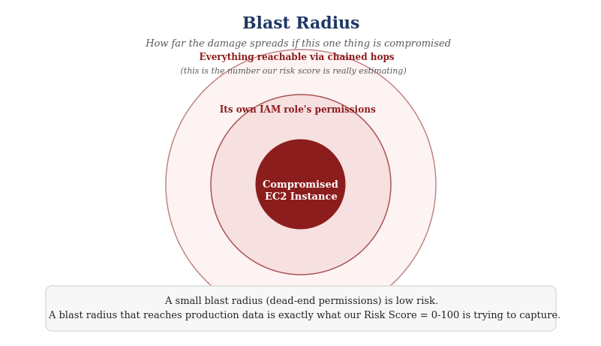
Figure 3. Blast radius, visually — the outer ring is what the risk score is really measuring.

Where to actually learn more
- Read the introduction sections of papers [2] (IAMPERE) and [6] (CloudLens) from our literature survey — both explain these concepts clearly before getting technical.
- AWS's own IAM documentation ("How IAM Works") is short, official, and free.

4. How Cartography's Intel Modules & Analysis Jobs Work
This is the one section that's specific to our exact base project rather than general knowledge. Every platform Cartography connects to (AWS, GitHub, Okta, 30+ others) is pulled in through the same repeating four-step pattern.
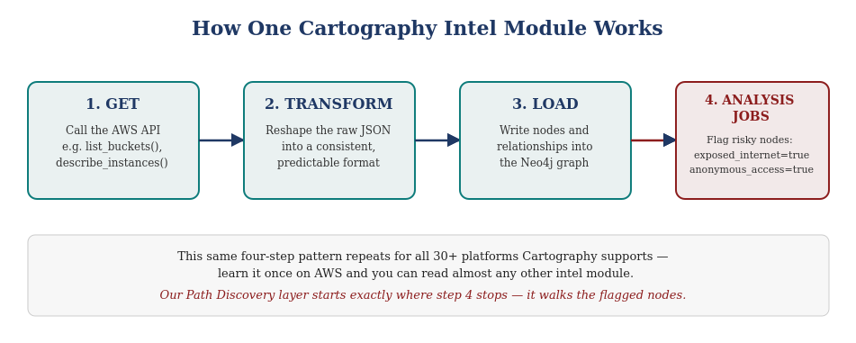
Figure 4. The get → transform → load → analyse pattern, repeated for every platform.
The first three steps just build the graph faithfully from what the cloud API actually returned. Step 4, Analysis Jobs, is where Cartography adds its own computed judgement — for example, deciding a load balancer counts as exposed_internet based on its configuration, even though the AWS API itself never labelled it that way.
Why this matters for our project specifically
Our Path Discovery layer doesn't reinvent step 4 — it reuses Cartography's existing exposed_internet and anonymous_access flags as its starting points, and searches outward from there. Understanding this pipeline is what lets you see exactly where our new code plugs in, and just as importantly, where it doesn't touch Cartography's own code at all.

Where to actually practice
- Read Cartography's "How to write a new intel module" developer doc — even if you never write one, reading one is the fastest way to understand the pattern.
- Open the AWS S3 intel module in Cartography's source code specifically — it's one of the shorter, more readable ones to start with.

You're Ready When...
- You can look at a Cypher query and describe in plain English what pattern it's searching for.
- You can explain the difference between privilege escalation and lateral movement without looking it up.
- You know that Cartography's analysis jobs are where our project's starting points come from.
- You're comfortable enough with Python to read a function, even if you couldn't yet write one from scratch.
That's genuinely the whole shared bar — everything past this point is specialisation.

